**COEN 317**

**Microprocessor Systems**

**EXPERIMENT #3**

**Using the AXI Hardware Timer**

**Name : Nicholas Gattuso**

**Section : U-UI**

"I certify that this submission is my original work and meets the Faculty’s Expectations of Originality",

# Objectives

The objectives of the lab are to become familiar with the AXI timer on the Xilinx ZC702 development board. Additionally, it is also to gain experience with the PlanAhead tools, the Xilinx Platform Studio, and the SDK.

# Introduction

# In this lab, we are introduced to the LogiCORE IP AXI Timer, an IP core containing two hardware counters. Throughout the lab, we use the timer in three different modes: a simple timer/counter, timer in capture, and timer as a PWM.

The first part of the lab is given with us to follow the steps in order to familiarize ourselves with the setup of the AXI Timer. From there, we are given modifications to make for our part 2 in order to implement the capture. To do this, we need to assign values to the registers and access registers using the address. This is given in table 1 of the lab manual with the modifications to make in the code following it. In addition, we have been provided with the AXI Timer DS764 manual in order to find more information such as the layout for the control and status registers. Lastly, with the modifications made in part 2, we can then proceed to part 3 where we implement a counter using the Pulse Width Modulator. In this part, we modify the code from part 2 and the set the correct values through a calculation of what they should be in the control/status register.

For more information on the lab, please refer to the lab manual. In addition, please refer to the AXI Timer DS764 manual.

# Results

Part 1

Please note, my SDK for some reason wasn’t allowing me to enter the values. This can be seen in the first picture where it continues the program before I can even enter a value. The following is the result after completing the steps: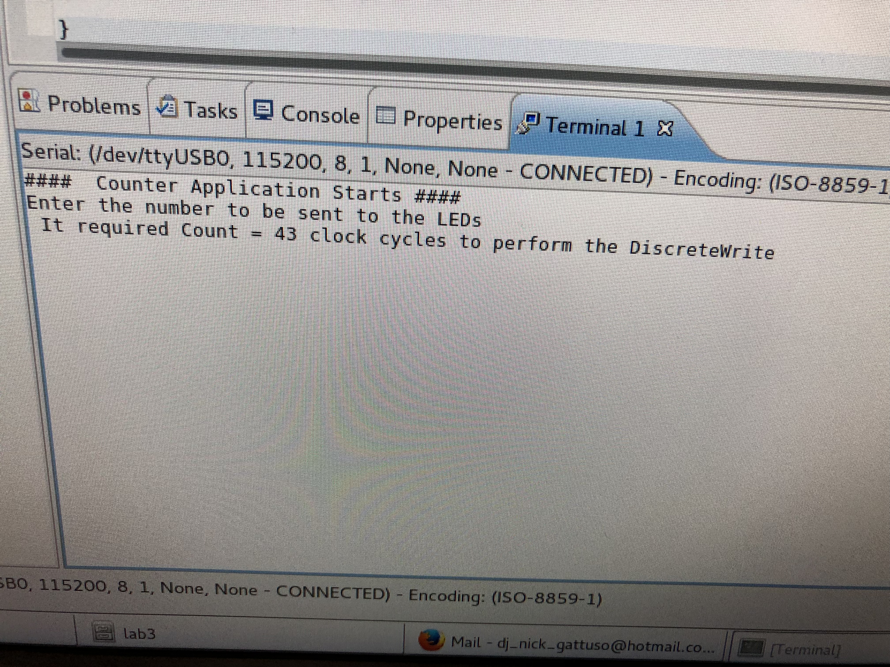

Following this, the code was modified as given in the lab manual to implement the alternative way to interface with the AXI Timer. This way uses the registers and addresses of the AXI Timer. When the connections were made in the XPS, the addresses and controls were already implemented to the registers. Therefore, for this modified code, we just need to assign the values that will be written into the register and read from the register. The result is:

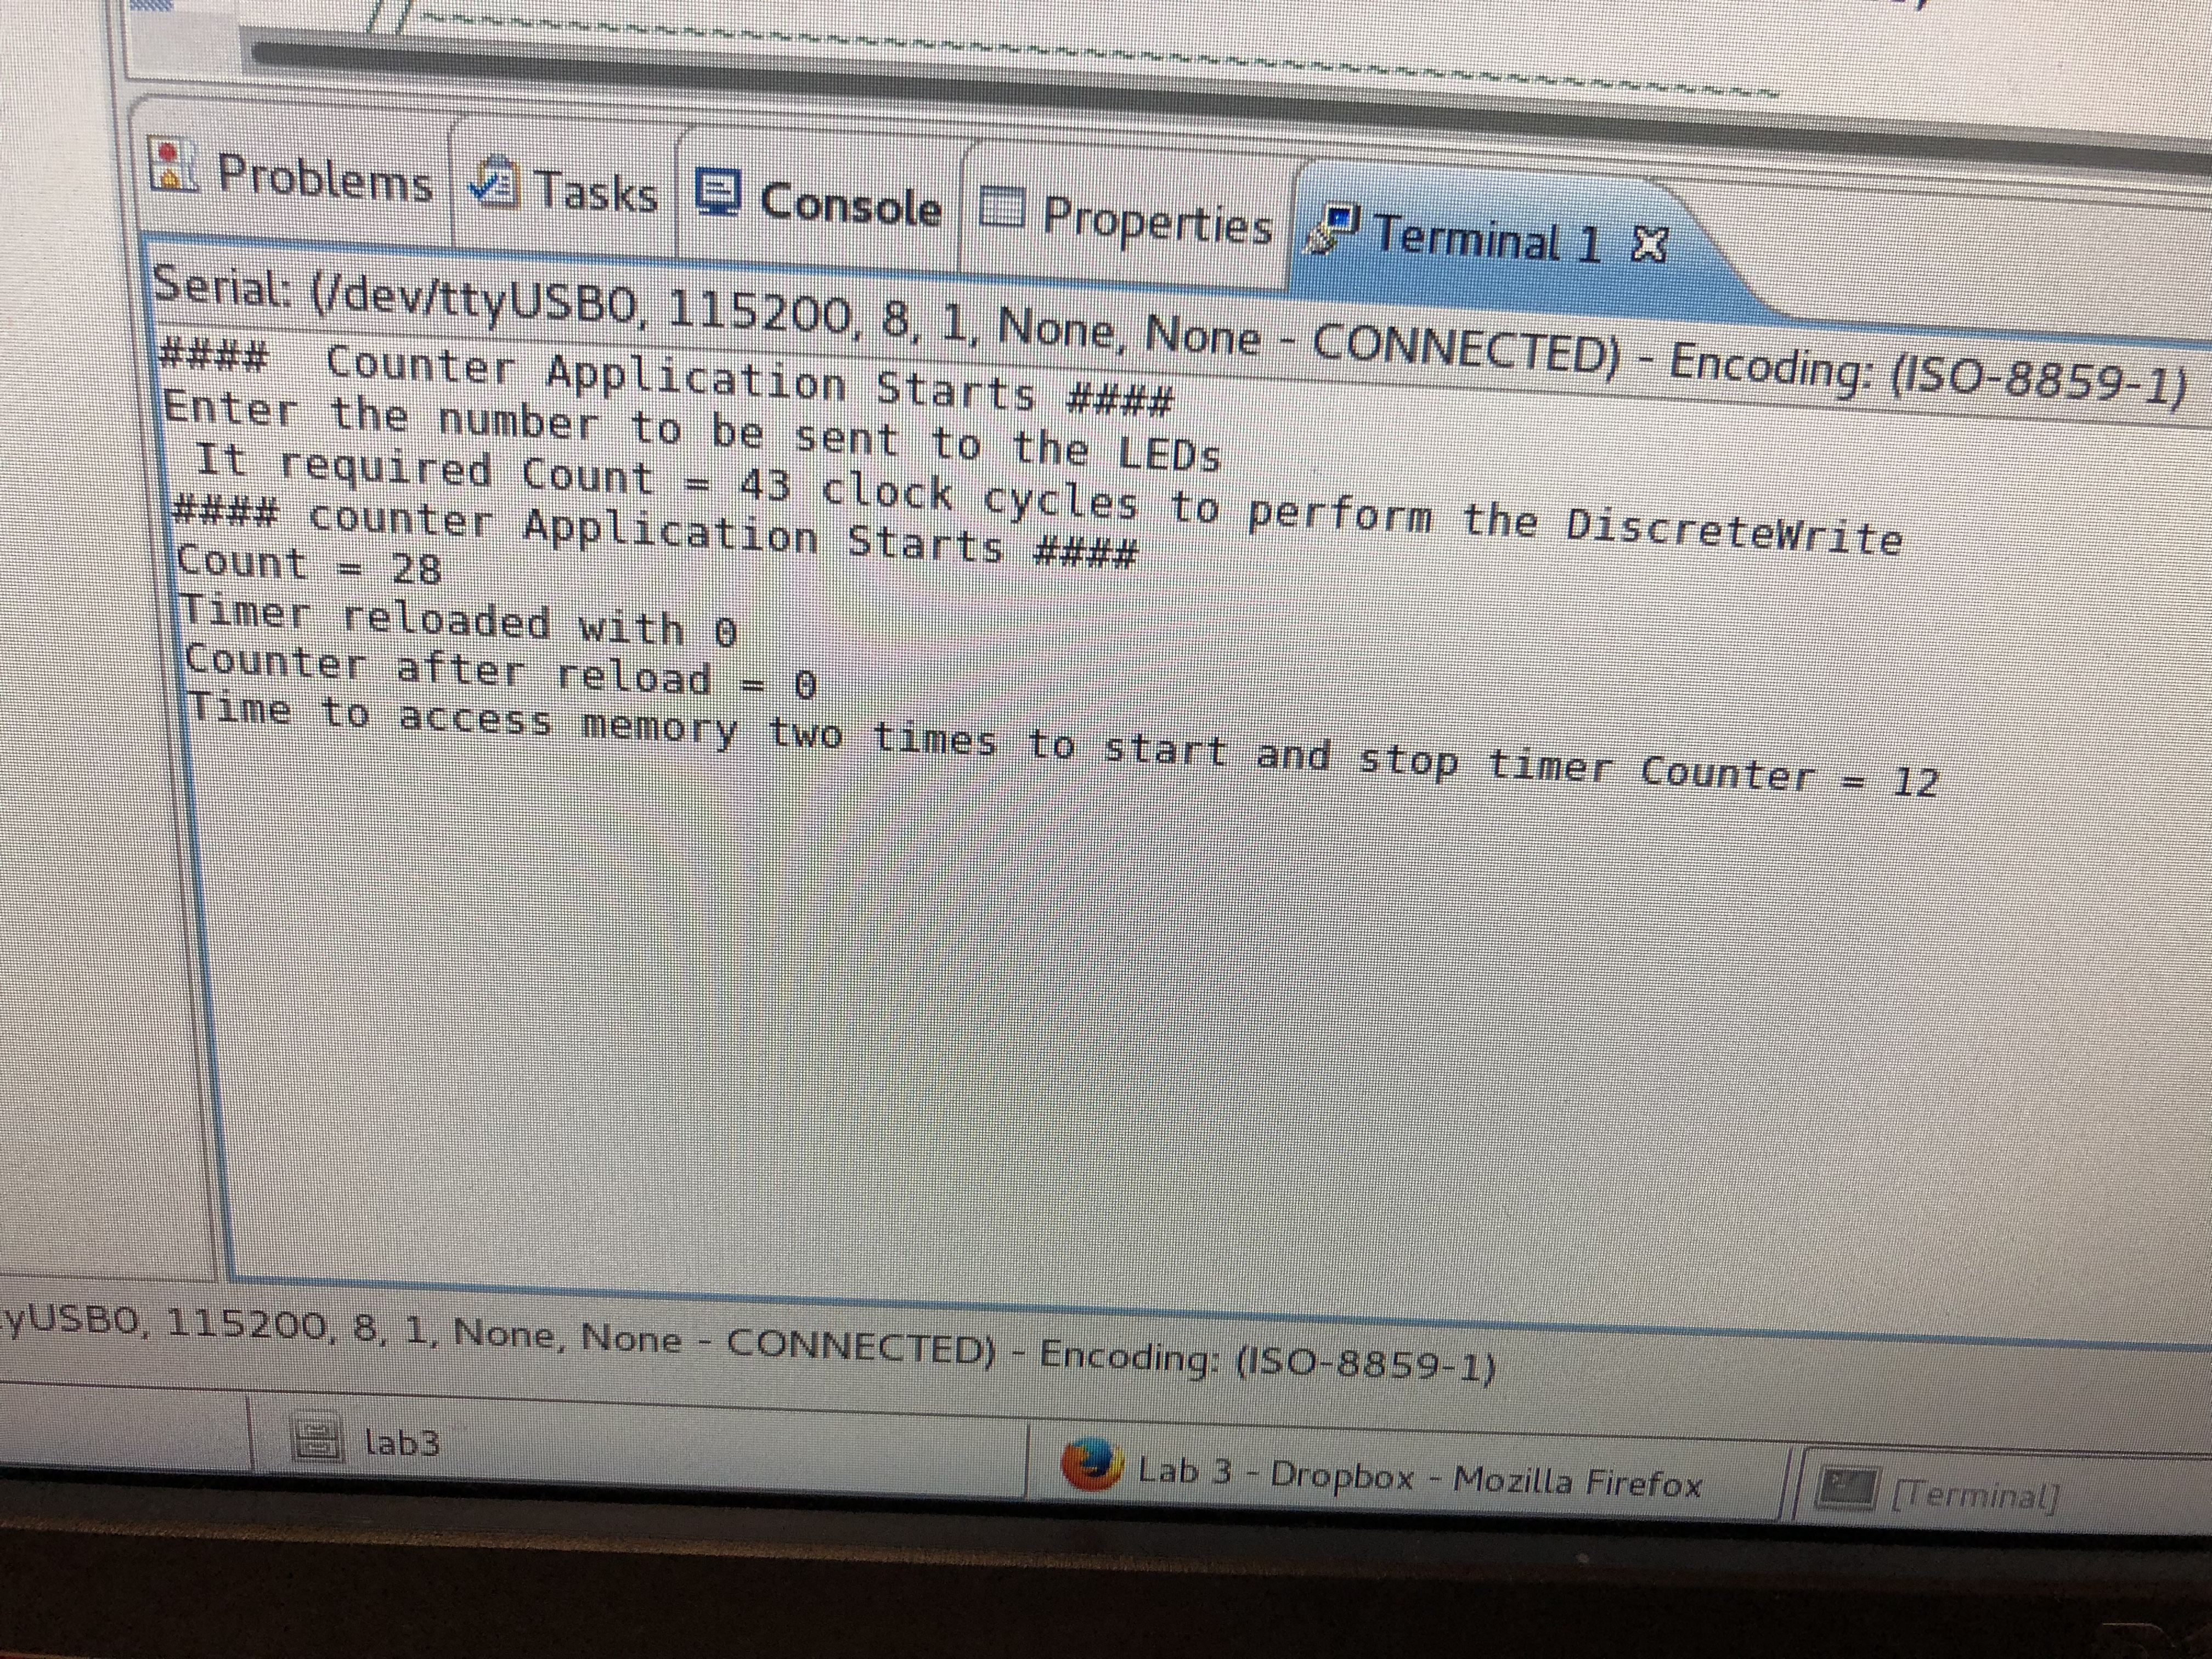

*Question 1:* using the deference pointer method (second version) results in a time of 28 clock cycles. This is about 65% faster than using the Discrete Write method.

*Question 2:* capture mode can save the count value inside a load register. A generate mode produces a one clock cycle pulse on the Generate output. In this situation, we want to read only at a certain points in time. For this situation, both modes will be able to perform the task. The question on which one to use depends on exactly what do you want to do after, generate a periodic pulse or save the counter?

Part 2

In this part, we are asked to implement the capture mode of the AXI Timer. The modifications weren’t too difficult as the lab manual provides a short context on what to modify, what to add in the UCF, and a pseudo code of the main.cc.

Unfortunately, I didn’t get a chance to reach the SDK because IMPACT would fail to recognize the cable connections. Despite many attempts to reconnect the cables and restart IMPACT, it never connected. Because of that, I could generate the program for the target.

If I forget to show it, please remind me. I’ll try to open it up on Monday before doing my demo for lab 3 to see if it will work. And, if it doesn’t, I’ll show it to you.

Please note (update Nov. 20), I just ran Impact and it managed to detect the cables. Unfortunately, I don't have time to go into the SDK because I must begin working on the lab 4.

Part 3

In this part, we are asked to implement the PWM mode for the AXI Timer. Following the small changes mentioned in the lab, I made it to the SDK where I wrote the program for the main. To write the program, I referred to the pseudo code given in part 2 for the order of the process, the equations to calculate the period and the high time given in the lab manual, and the pseudo code given in part 3 for what the procedure should be. Additionally, I referred to the AXI Timer DS764 manual to find which bits I need to set and which registers to use. In the end, I managed to get the second light to dim thus, validating the code.

The following is the code:

#include "stdbool.h"

#include "xparameters.h"

#include "xil_types.h"

#include "xgpio.h"

#include "xil_io.h"

#include "xil_exception.h"

#include "xtmrctr.h"

#include <iostream>

using namespace std;

int main()

{

//modified from the code completed in the prelab

static XGpio GPIOInstance_Ptr;

u32* timerPtr = (u32*) XPAR_TMRCTR_0_BASEADDR; //creating a u32 variable that points to the address

int xStatus;

cout << "#### Counter Application Starts ####" << endl;

//~~~~~~~~~~~~~~~~~~~~~~~~~~~~~~~~~~~~~~~~~~~~~~~~

//Step-1: AXI GPIO Initialization

//~~~~~~~~~~~~~~~~~~~~~~~~~~~~~~~~~~~~~~~~~~~~~~~~

xStatus = XGpio_Initialize(&GPIOInstance_Ptr, XPAR_AXI_GPIO_FOR_OUTPUT_DEVICE_ID);

if(xStatus != XST_SUCCESS)

{

cout << "GPIO A Initialization FAILED" << endl;

return 1;

}

//~~~~~~~~~~~~~~~~~~~~~~~~~~~~~~~~~~~~~~~~~~~~~~~~

//Step-2: AXI GPIO Set the Direction

//~~~~~~~~~~~~~~~~~~~~~~~~~~~~~~~~~~~~~~~~~~~~~~~~

//XGpio_SetDataDirection(XGpio *InstancePtr, unsigned Channel, u32 DirectionMask);

//we use only channel 1, and 0 is the the parameter for output

XGpio_SetDataDirection(&GPIOInstance_Ptr, 1, 0);

//~~~~~~~~~~~~~~~~~~~~~~~~~~~~~~~~~~~~~~~~~~~~~~~~

//Step-3: PMW Timer Initialization and Setting

//~~~~~~~~~~~~~~~~~~~~~~~~~~~~~~~~~~~~~~~~~~~~~~~~

*timerPtr = 0x206; //setting the control/status of reg0's PWM's timer to enable pulse width, enabling generate mode and, enable count down

*(timerPtr + 4) = 0x206; //setting the second timeer's control/status

//~~~~~~~~~~~~~~~~~~~~~~~~~~~~~~~~~~~~~~~~~~~~~~~~

//Step-4: Setting the Timer Option

//~~~~~~~~~~~~~~~~~~~~~~~~~~~~~~~~~~~~~~~~~~~~~~~~

//the following are variables to control the timer

float cycleTime; //variable for the duty cycle

float periodTimer; //variable for the period

cout << "Enter duty cycle time: " << endl; cin >> cycleTime;

cout << "Enter period (s): " << endl; cin >> periodTimer;

//----------perform the PWM--------------------------

while(true){

//50000000Hz (given in lab)

*(timerPtr + 1) = (periodTimer * 50000000) -2; // put results in loads

*(timerPtr + 5) = (periodTimer*(cycleTime/100)*50000000)-2; //putting percentage of duty in the timer 2's load

//change controls to enable load the values from above into the timer

*timerPtr = 0x226;

*(timerPtr + 4) = 0x226;

//change control to stop load and enable the counter

*timerPtr = 0x286;

*(timerPtr + 4) = 0x286;

}

return 0;

}

# Conclusion

In conclusion, the objectives of the lab were met. Despite my SDK not allowing me to enter values and IMPACT stopping me from completing the Capture mode, I still managed to learn and understand how to use the AXI Timer. I managed to learn the registers and the different control/status.